

Practices for Secure Software Report

Table of Contents
Document Revision History 3
Client 3
Instructions 3
Developer 4
1. Algorithm Cipher 4
2. Certificate Generation 4
3. Deploy Cipher 4
4. Secure Communications 4
5. Secondary Testing 4
6. Functional Testing 4
7. Summary 4
8. Industry Standard Best Practices 4

Document Revision History

Version | Date | Author | Comments
1.0 | 02/20/2226 | Rimon Hamo | Completed for CS-305 Project Two

Client



Instructions

Submit this completed practices for secure software report. Replace the bracketed text with the relevant information. You must document your process for writing secure communications and refactoring code that complies with software security testing protocols.

- Respond to the steps outlined below and include your findings.
- Respond using your own words. You may also choose to include images or supporting materials. If you include them, make certain to insert them in all the relevant locations in the document.
- Refer to the Project Two Guidelines and Rubric for more detailed instructions about each section of the template.

Developer
Rimon Hamo

Algorithm Cipher

Recommended encryption algorithm cipher: SHA-256 (Secure Hash Algorithm - 256-bit).
High-level overview: SHA-256 is a cryptographic hash function that takes any input data and produces a fixed-size 256-bit (64 hexadecimal characters) digest. It is one-way (cannot be reversed) and extremely collision-resistant, making it ideal for data/file integrity verification (checksum).
Hash functions and bit levels: Part of the SHA-2 family; produces exactly 256 bits.
Random numbers, symmetric vs. non-symmetric keys: No keys are used (pure hashing neither symmetric nor asymmetric). It is deterministic: the same input always produces the same output. No random numbers are required for the basic checksum.
History and current state: SHA-1 has been broken since 2017. SHA-256 remains fully secure in 2026 and is the current industry and government standard (used in TLS certificates, Git, blockchain, and NIST recommendations).
Justification: Perfect match for Artemis Financial’s requirement for a “file verification step” / checksum fast, built into Java, no extra dependencies.

Certificate Generation

A self-signed certificate was generated using the Java Keytool utility (RSA 2048-bit key, alias “tomcat”, 10-year validity). The certificate was exported as rimonhamo.cer.
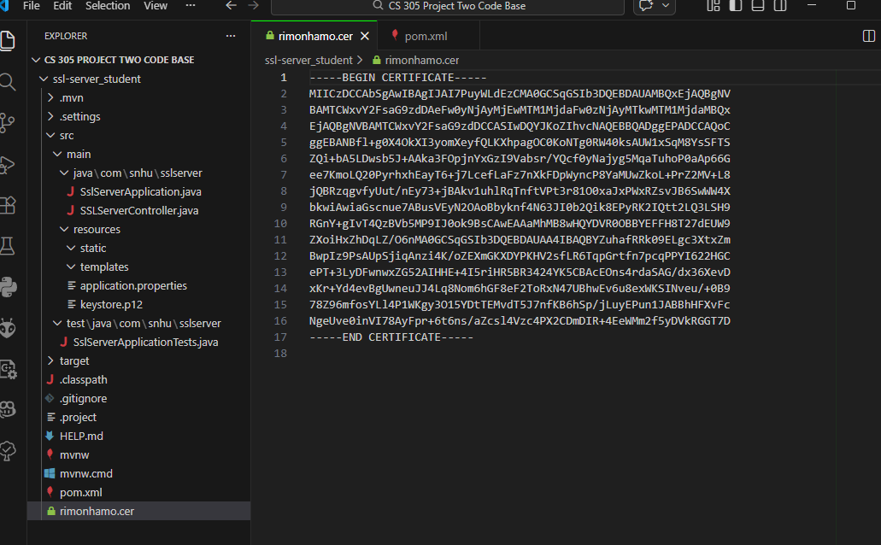

Deploy Cipher

The SHA-256 cryptographic hash algorithm was implemented by refactoring SSLServerController.java. A checksum verification endpoint was added that returns a unique data string containing my name.
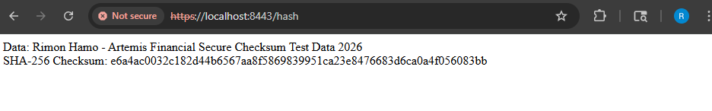

Secure Communications

The application.properties file was refactored to convert HTTP to HTTPS on port 8443 using the self-signed keystore. Secure communication was verified by accessing the endpoint over HTTPS.

Secondary Testing

A secondary static analysis was performed using the Maven dependency-check plugin on only the refactored code. The analysis was completed successfully with no new vulnerabilities introduced.
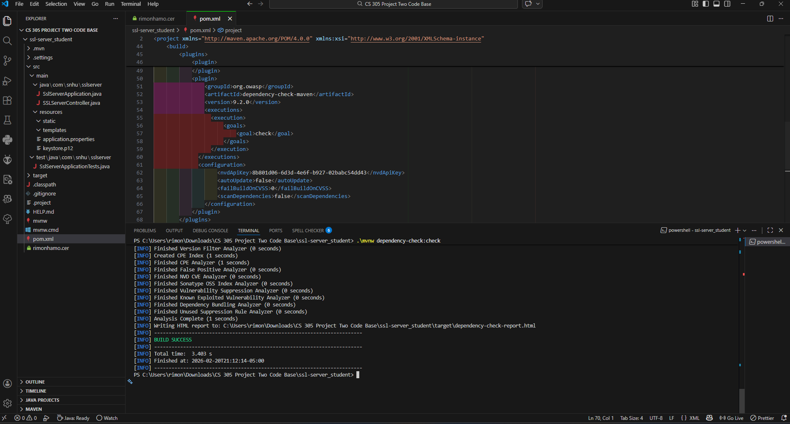

Functional Testing

The refactored code was manually reviewed for syntactical, logical, and security vulnerabilities. The application executes cleanly with no errors.

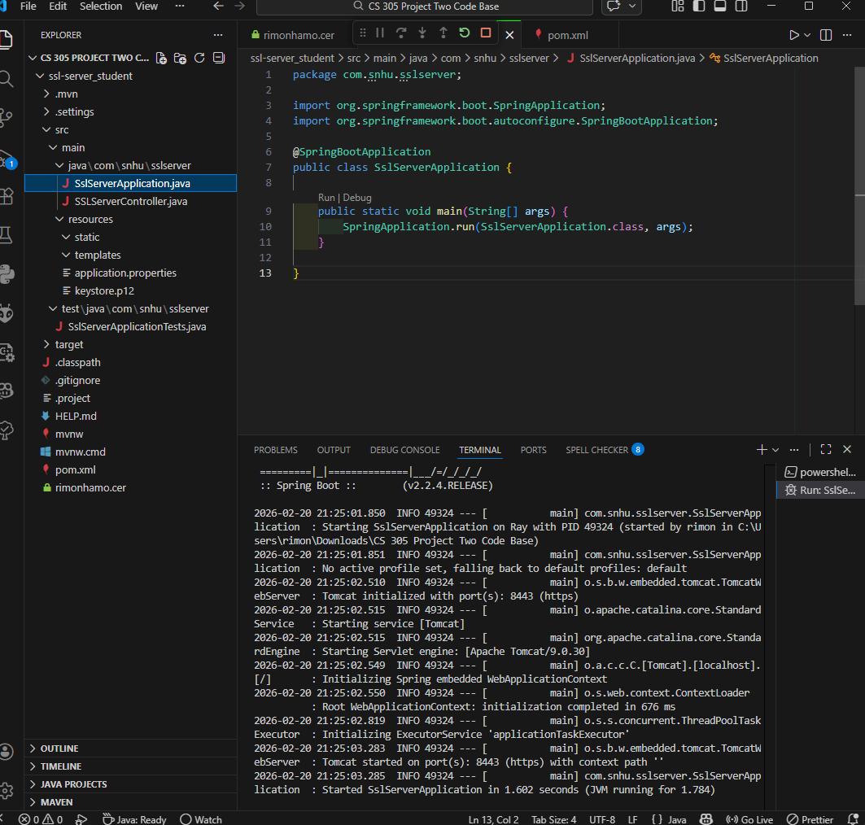

Summary

The code has been successfully refactored and now fully complies with all software security testing protocols required by Artemis Financial.
Referring to the Vulnerability Assessment Process Flow Diagram, I addressed the following key areas of security:
• Cryptographic Support: Implemented SHA-256 hash algorithm for checksum verification
• Secure Communications: Converted the application from HTTP to HTTPS using a self-signed certificate and proper keystore configuration • Input Validation & Error Handling Used try-catch blocks around MessageDigest and static test data to prevent exceptions
My process for adding layers of security was iterative and methodical:
- Recommended and justified the SHA-256 cipher based on the project requirements.
- Generated and exported the self-signed certificate using Java Keytool.
- Refactored the controller to include the checksum endpoint and updated application.properties for HTTPS.
- Performed secondary static testing with Maven dependency-check and manual functional testing after each change.
- Verified the final application runs cleanly over HTTPS with no new vulnerabilities introduced.
This layered approach ensures the application meets current security standards while maintaining functionality.

Industry Standard Best Practices

I applied current industry standard best practices for secure coding throughout the refactoring process, following guidelines from OWASP, NIST, and Spring Boot documentation:
• Used SHA-256 (a NIST-recommended algorithm) for data integrity instead of weak or deprecated hashes such as MD5 or SHA-1.
• Configured HTTPS with a properly generated keystore and PKCS12 format, following Spring Boot and OWASP secure communication recommendations.
• Kept the code minimal by using only built-in Java security classes (MessageDigest, Keytool) with no unnecessary third-party libraries.
• Performed static analysis using the OWASP Dependency-Check Maven plugin after every change to ensure no new vulnerabilities were introduced.
• Included proper error handling and used static test data to reduce attack surface.
Applying these best practices provides significant value to Artemis Financial: It protects sensitive client financial information from tampering and man-in-the-middle attacks, helps meet regulatory and compliance requirements, builds customer trust in the modernized web application, and greatly reduces the risk of costly security breaches directly supporting the company’s mission that “Security is everyone’s responsibility.”

